# Experiment #8 Pre-Lab

# Alan Palayil

# Preliminary Assignment:

2. Use information provided in *Appendix D* and *Reference 8*, draw a schematic of wiring between Raspberry Pi 3 and Adafruit ADXL345 using I2C. Show your work to your TA in the beginning of the lab.

3. Use information provided in Appendix D and Reference 8, draw a schematic of wiring between Raspberry Pi 3 and Adafruit ADXL345 using SPI. Show your work to your TA in the beginning of the lab.

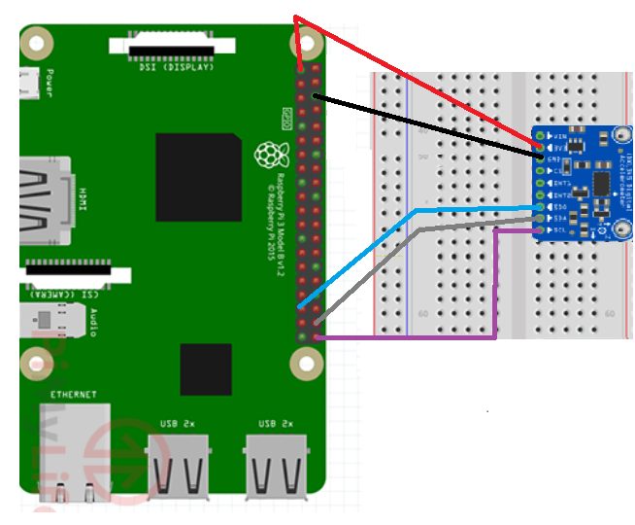

5. Implement the program as required in procedure A.2. Write the program with proper comments, explain how you implemented such program to your TA in the beginning of the lab.

#include <stdio.h>

#include <signal.h>

#include <sys/time.h>

#include "i2c-dev.h"

#include "ADXL345.h"

#define I2C_FILE_NAME "/dev/i2c-1" // for Rpi Bt

void INThandler(int sig);

int main(int argc, char **argv)

{

// Open a connection to the I2C userspace control file.

int i2c_fd = open(1I2C_FILE_NAME, O_RDWR);

if (i2c_fd < 0)

{

printf ("Unable to open i2c control file, err~%d\n", i2c_fd);

exit(1);

}

printf ("Opened i2c control file, id~%d|n", i2c_fd);

ADXL345 myAcc(i2c_fd);

int ret = myAcc.init();

if (ret)

{

printf ("failed init ADXL345, ret=%d\n"; ret);

exit(1);

}

usleep(100 * 1000);

signal (SIGINT, INThandler);

short ax,ay,az;

// create file IO

FILE *fp;

fp = fopen("./output.txt","w+");

char TimeString[128];

timeval curTime;

while (1)

{

//get the current time

gettimeofday(&curTime, NULL);

strftime(TimeString, 80, "%Y-%m-%d %H:%M:%S", localtime (&curTime.tv_sec));

printf (TimeString);

// now, fetch data from sensor

myAcc.readXYZ(ax,ay,az);

//print to screen

printf ("Ax : %hi \t Ay : %hi \t Az: %hi \n",ax,ay,az);

printf ("------------------ \n");

//print to file

fprintf(fp,TimeString);

fprinet(fp, “: “);

fprintf(fp, "Ax : %hi \t Ay : %hi \t Az: %hi \n",ax,ay,az);

fprintti(tp, "---------------\n");

if (getchar() == 'q') break;

}

fclose (fp);

return 0;

}

void INThandler(int sig)

{

signal(sig, SIG_IGN);

exit(0);

}

6. Implement the program as required in procedure B.2. Write the program with proper comments, explain how you implemented such program to your TA in the beginning of the lab.

7. Familiar yourself with the client-server program architecture as explained in procedure B, implement the program that sending data to server. Explain how you implemented such program to your TA in the beginning of the lab.